Rule 1
R1 PaymentTypeInformationRule
If PaymentTypeInformation is present, then CreditTransferTransactionInformation/PaymentTypeInformation is not allowed

If
2.6 |  | ++PaymentTypeInformation | <PmtTpInf> | [0..1] | Component | Required | Set of elements that further specifies the type  of transaction.
2.31 |  | +++PaymentTypeInformation | <PmtTpInf> | [0..1] | Component | Conditional | Set of elements that further specifies the type  of transaction.
must not be populated
Comment:

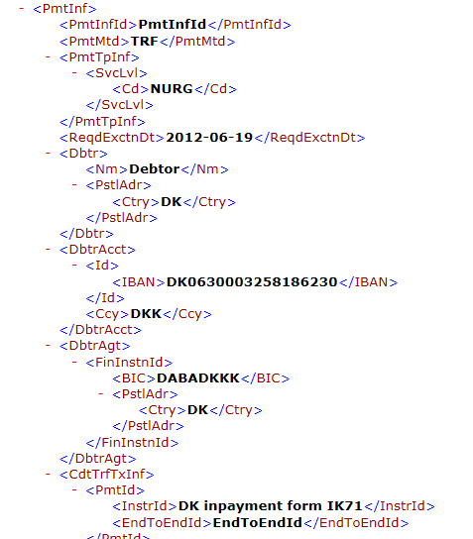

Rule 3
R3 ChargesAccountRule
If ChargesAccountAgent is present, then ChargesAccount must be present

If

2.26 + |  | ++ChargesAccountAgent | <ChrgsAcctAgt> | [0..1] | Financial  Institution  Identification | Agent that services a charges account. | Not used

is populated,
2.25 + |  | ++ChargesAccount | <ChrgsAcct> | [0..1] | Component | Account used to process charges associated with a transaction.  Usage: charges account should be used when charges have to be booked to an account  different from the account identified in debtor’s  account. | Not used
must also be populated
Comment:
ChargesAccountAgent is not used in Denmark. Is this rule therefore not relevant?

Rule 4
R4 ChargesAccountAgentRule
If ChargesAccountAgent is present, then it must contain a branch of the DebtorAgent. It must not contain a completely different agent.
This Rule also impacts BranchAndFinancialInstitutionIdentification4

If

2.26 + |  | ++ChargesAccountAgent | <ChrgsAcctAgt> | [0..1] | Financial  Institution  Identification | Agent that services a charges account. | Not used

is populated,
2.21 + |  | ++DebtorAgent | <DbtrAgt> | [1..1] | Financial  Institution Identification Component | Financial institution servicing an account for the debtor. | M*
must not be populated
Comment:
Also applies to BranchAndFinancialInstitutionIdentification4. This element is not present in the schema.
ChargesAccountAgent is not used in Denmark. The rule is not relevant.

Rule 5
R5 ChargeBearerRule
If ChargeBearer is present, then CreditTransferTransactionInformation/ChargeBearer is not allowed.
If CreditTransferTransactionInformation/ChargeBearer is present, then ChargeBearer is not allowed.

CreditTransferTransactionInformation/ChargeBearer and ChargeBearer may both be absent.

If
2.24 |  | ++ChargeBearer | <ChrgBr> | [0..1] | Code | Conditional | Specifies which party/parties will bear the charges associated with the processing of the payment transaction.
is populated,
2.51 |  | +++ChargeBearer | <ChrgBr> | [0..1] | Code | Conditional | Specifies which party/parties will bear the charges associated with the processing of the payment transaction.
must not be populated
Comment:
The reverse also applies: if 2.24 is populated, 2.51 must not be populated.
CreditTransferTransactionInformation/ChargeBearer and ChargeBearer may both be absent.

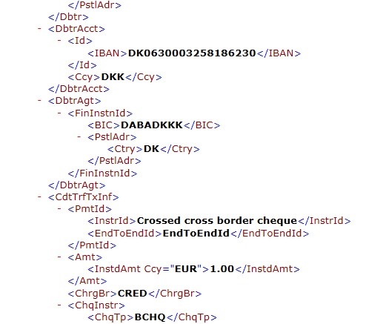
Rule 6
R6 UltimateDebtorRule
If UltimateDebtor is present, then CreditTransferTransactionInformation/ UltimateDebtor is not allowed.
If CreditTransferTransactionInformation/UltimateDebtor is present, then UltimateDebtor is not allowed.

CreditTransferTransactionInformation/UltimateDebtor and UltimateDebtor may both be absent.

If
2.23 + |  | ++UltimateDebtor | <UltmtDbtr> | [0..1] | Party  Identification  Component | Conditional | Ultimate party that owes an amount of money to the (ultimate) creditor.
is populated,
2.70 + |  | +++UltimateDebtor | <UltmtDbtr> | [0..1] | Party  Identification  Component | Conditional | Ultimate party that owes an amount of money to the (ultimate) creditor.
must not be populated
Comment:
The reverse also applies: if 2.70 is populated, 2.23 must not be populated.
CreditTransferTransactionInformation/UltimateDebtor and UltimateDebtor may both be absent.

Rule 10
R10 TransferPaymentMethodRule
If PaymentMethod is TRF and CreditTransferTransactionInformation/Creditor is not present, then
CreditTransferTransactionInformation/CreditorAccount must be present.

If
2.2 |  | ++PaymentMethod | <PmtMtd> | [1..1] | Code | Required | Specifies the means of payment that will be used to move the amount of money.
is “TRF” and
2.79 + |  | +++Creditor | <Cdtr> | [0..1] | Party  Identification  Component | Required | Party to which an amount of money is due.
is not populated, then
2.80 + |  | +++CreditorAccount | <CdtrAcct> | [0..1] | Cash Account  Component | Required | Unambiguous identification of the account of the creditor to which a credit entry will be posted as a result of the payment transaction.
Comment:

Rule 12
R12 IntermediaryAgent2Rule
If IntermediaryAgent2 is present, then IntermediaryAgent1 must be present.

If

2.6 |  | ++PaymentTypeInformation | <PmtTpInf> | [0..1] | Component | Set of elements that further specifies the type of transaction. | M

is populated, then
2.27 |  | ++CreditTransferTransactionInformation | <CrdtTrfTxInf> | [1..n] | Component | Set of elements providing information to the individual transaction(s specific) included in the message. | M
must not be populated
Comment:
IntermediaryAgent 1 and 2 are not used

Rule 13
R12 IntermediaryAgent2Rule
If IntermediaryAgent2 is present, then IntermediaryAgent1 must be present.

If

2.6 |  | ++PaymentTypeInformation | <PmtTpInf> | [0..1] | Component | Set of elements that further specifies the type of transaction. | M

is populated, then
2.27 |  | ++CreditTransferTransactionInformation | <CrdtTrfTxInf> | [1..n] | Component | Set of elements providing information specific  to the individual transaction(s) included in the message. | M
must not be populated
Comment:
IntermediaryAgent 1 and 2 are not used

Rule 15
R15 IntermediaryAgent1AccountRule
If IntermediaryAgent1Account is present, then IntermediaryAgent1 must be present.

If

2.6 |  | ++PaymentTypeInformation | <PmtTpInf> | [0..1] | Component | Set of elements that further specifies the type of transaction. | M

is populated, then
2.27 |  | ++CreditTransferTransactionInformation | <CrdtTrfTxInf> | [1..n] | Component | Set of elements providing information specific  to the individual transaction(s) included in the message. | M
must not be populated
Comment:
IntermediaryAgent1Account is not used

Rule 16
R16 IntermediaryAgent2AccountRule
If IntermediaryAgent2Account is present, then IntermediaryAgent2 must be present.

If

2.6 |  | ++PaymentTypeInformation | <PmtTpInf> | [0..1] | Component | Set of elements that further specifies the type of transaction. | M

is populated, then
2.27 |  | ++CreditTransferTransactionInformation | <CrdtTrfTxInf> | [1..n] | Component | Set of elements providing information specific  to the individual transaction(s) included in the message. | M
must not be populated
Comment:
IntermediaryAgent2Account is not used

Rule 17
R17 IntermediaryAgent3AccountRule
If IntermediaryAgent3Account is present, then IntermediaryAgent3 must be present.

If

2.6 |  | ++PaymentTypeInformation | <PmtTpInf> | [0..1] | Component | Set of elements that further specifies the type of transaction. | M

is populated, then
2.27 |  | ++CreditTransferTransactionInformation | <CrdtTrfTxInf> | [1..n] | Component | Set of elements providing information specific  to the individual transaction(s) included in the message. | M
must not be populated
Comment:
IntermediaryAgent3Account is not used

